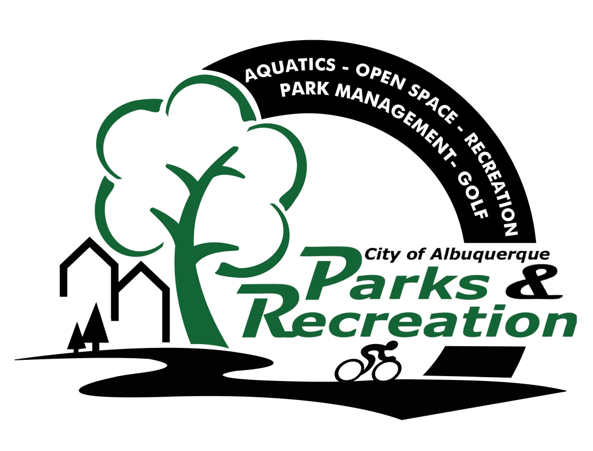

City of Albuquerque
Parks & Recreation Department
2014 Seasonal Indoor Track
Waiver and Release

I_______________________________ hereby acknowledge that my participation at the indoor track facility located at the Albuquerque Convention Center is entirely voluntary on my part. I also understand that all exercises may be inherently dangerous and is undertaken at my sole risk. I also understand that my use of all machinery, equipment, and apparatus designed for exercising is at my sole risk. I fully recognize and understand the dangers arising from surface detrimental physiological and psychological changes may occur during any exercise program. The changes could include heat-related illness, abnormal heartbeat, abnormal blood pressure, respiratory problems, and/or heart related illness, abnormal heartbeat, abnormal blood pressure, respiratory problems, and/or heart problems.

I further understand that the risks involved in exercises depend upon many factors including, but not limited to, age, level of conditioning, health status, coronary heart disease risk factors, and the frequency and duration of exercise. I agree and promise to obtain and complete a medical examination and physician approval before beginning any exercise program. If I am more than 40 years of age, have heart trouble, high blood pressure, frequent severe dizzy spells, diabetes, or have any other condition that may affect my ability to exercise safely, I will provide proof of such examination and approval to staff. I attest and verify that I am physically able to take part in physical fitness activities.

Notwithstanding any consultation on exercise programs, I understand and agree that my selection of an exercise program and type of equipment shall be my sole responsibility. The City of Albuquerque shall not be liable to me for any claims, injuries, or damages sustained as a result of participating in the program.

Furthermore, I accept sole responsibility for monitoring my individual physical performance during exercise. In the event of any medical problem, I further recognize and agree that I am financially responsible for any medical care that I may require.

I hereby waive, release, and discharge for heirs, executors, administrators, and league representatives assigns, successors, and myself. In interest and all rights, claims, and cause of action at law, equity, or in contract, which I have or may hereafter, accrue to me against the City of Albuquerque.

I hereby waive any of its officers, agents, independent contractors, or employees for any and all damages I may sustain which are caused by or arise from my participation on the indoor track facility.

I agree, for my successors, and myself that these representatives are contractually binding, and not more recitals. Should my successors or shall I be liable for the damages incurred by the City of Albuquerque including its attorney fees and costs in defending the action.

I knowledge receipt of the waiver and liability release for the indoor track facility located at the Albuquerque Convention Center. I also acknowledge that I will comply with the rules and expectations of the indoor track facility. I have read the above conditions and accept them as shown by my signature:

_____________________________ _________________
Participant Signature Date

_____________________________
Staff Witness

